Credit Risk and Loan Approval Analysis
Nahum Ghebrehiwet
2/8/2026

Introduction:
Every year, millions of people around the world petition for loans to make payments they cannot afford in one session. Financial institutions such as banks provide necessary loans to people on the condition that they repay them gradually with interest. However, not everyone can repay the loans, and in some cases don’t. Financial institutions need to be able to accurately identify who can and can’t pay off loans if they are to have a profitable industry. In this analysis, we look at data from the Credit Bureau to find which types of loans are the safest and generate the most return.

Data:
The data is from the Credit Bureau Data on Kaggle. This dataset carefully resembles how information is recorded in the 3 major U.S credit bureau – Equifax, Experian, and TransUnion. The data was also modified to remove 3 rows where two of the person ages are listed as 144 and 123. The verified oldest human to ever live was 122 years old.

Method:
The analysis for this project involves using software programs such as SQL and Microsoft BI. The SQL commands in this project include count(), sum(), avg(), stddev(), group by, etc.

Analysis
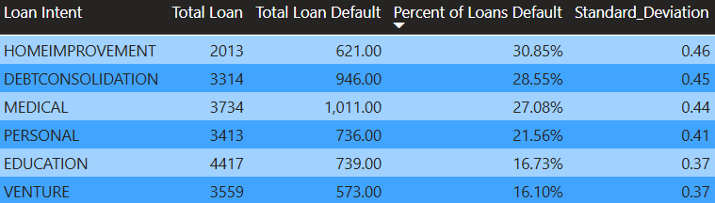
The table above shows the different intents of loans, ranging from home improvement to venture. The table shows the total amount of loans, defaulted loans, the percentage of loans defaulted, and the standard deviation for each loan intent. According to this table, home improvement, debt consolidation, and medical loans have the highest percentage of loan defaults. The standard deviation is also highest in these 3 loan intent categories. This likely means there are groups of borrowers in home improvement, debt consolidation, and medical loans who have a significantly high chance of loan default.

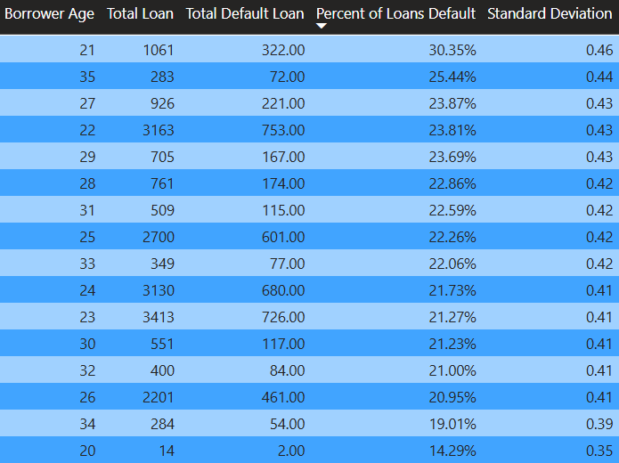
This graph above shows percent of loans default by age. Borrowers age 21 have the highest default rate percentage however there doesn’t seem to be a consistent trend or pattern with age.
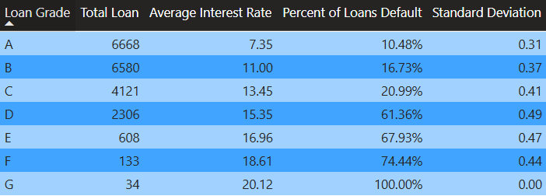
This table shows the average interest rate and percentage of loans defaulting for each loan grade. An important thing to notice is that loan grade from C and D see the most significant loan default percentage gap. Loan grade D also has the largest standard deviation for loan default percentage.
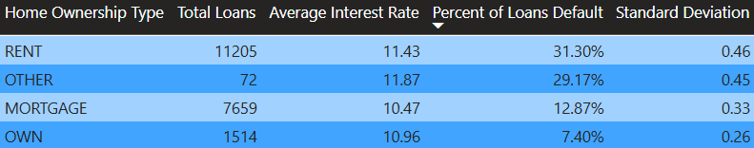
This table shows the percentage of loans that default by home ownership type. Rent has the highest risk of loan default.
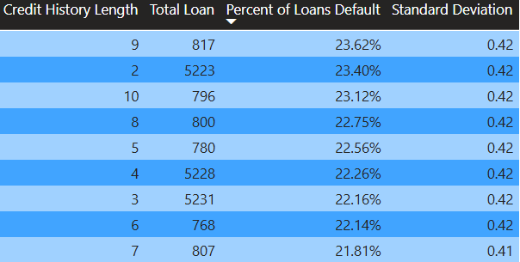
This table shows the percentage of loans that default by credit history. This table shows there is very little correlation with credit history length and loan default percentage.

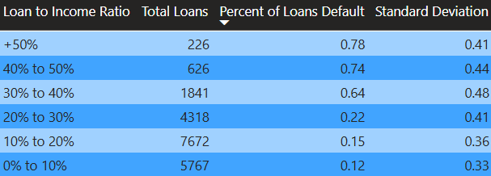
This table shows loan to income ratio with the percentage of loans defaulting. A significant thing to note is that there is a significant gap between the 20-30% and 30-40% gap. The standard deviation is also highest in the 30-40%
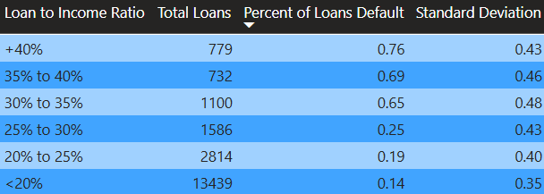
This table also shows loan to income ratio with the percentage of loans defaulting. The difference is that the category threshold is changed to further look into the percentage of loans defaulting between 20-40%. There is a huge gap in the loan default percentage between 25-30% and 30-35%.
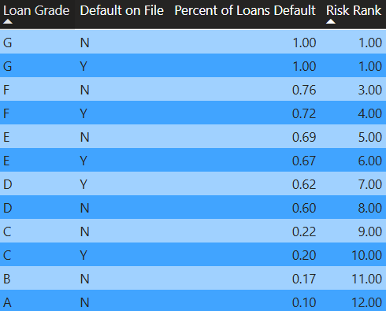
This table shows percent of loan defaults by loan grade and default on file. This reaffirms percent of loans that default is significantly higher at D, even when controlling for whether borrowers previously defaulted.

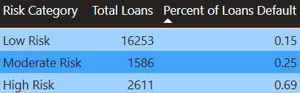
This table categorizes percent of loan defaults by low, moderate, and high risk. Low risk has below 25% loan default, moderate risk has between 25-30% loan default, and high risk has above 30% loan default.

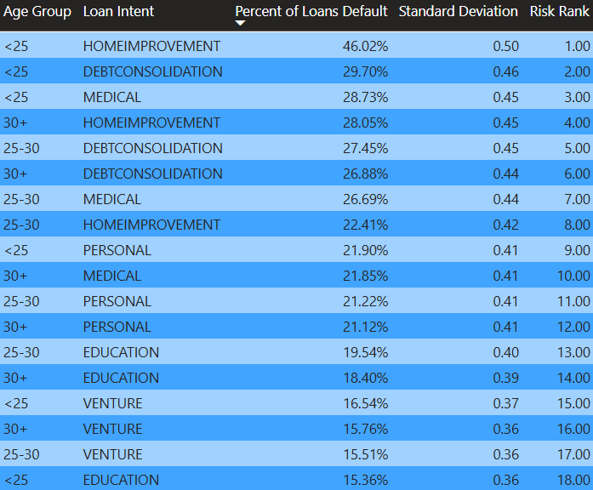

The last table shows the percentage of loans defaulting by age group and loan intent. Under-25 borrowers have the highest loan default percentage for all categories except education. Standard deviation also appears to be positively correlated with the percentage of loans that default.

Results:
When compiling all the data analyzed from the credit bureau. There are several key findings. The demographics most at risk of defaulting on loans are borrowers aged 21, except for education, home improvement loans, loan grades D-G, renters, and borrowers who take out loans exceeding 30% of their income.

Conclusion:
New data analytics technologies make it easier to accurately determine if loans should be approved. Financial institutions that provide loans ought to conduct accurate risk assessments on borrowers. Careful loan approval analysis can help minimize loan defaults, which benefits both borrowers and lenders. With the analysis completed in this report, credit bureaus should carefully look into and possibly reform loan approvals for high-risk borrowers.

